**Employment Form User Guide**

**Read the below instructions carefully before you proceed with the form.**

1. The excel is not compatible for Apple / Mac users. Request you to update the the form using microsoft enabled system.
2. Save the zip folder on the desktop before you start working on the form, extract the file and then start updating it.
3. Incase you face a ‘Compile Error’ in the hidden module, then close all the excel’s in the background and save the (empty file onboarding) on the desktop before opening the attached Macro.
4. To trouble shoot any ‘Runtime Errors’ faced while using the macro file, follow below steps:

**Ctrl + Alt + Delete** 🡪 **Task Manager 🡪 Windows Task Manager 🡪 Processes 🡪**

**EXCEL.EXE *32 🡪 End Process**

1. Ensure to enable macro’s in your system by following the below steps:

**Open Excel 🡪 Go to file 🡪 Options 🡪 Trust Center 🡪 Trust Center Settings 🡪 Macro Settings 🡪 Check “trust access to the VBA project object model” 🡪 OK**

1. Double click on tab to enter the date/month/year. Do not type.

**Refer to the below snapshots for easy navigation**

1. Open the Macro file, Click enable content to start using the macro.

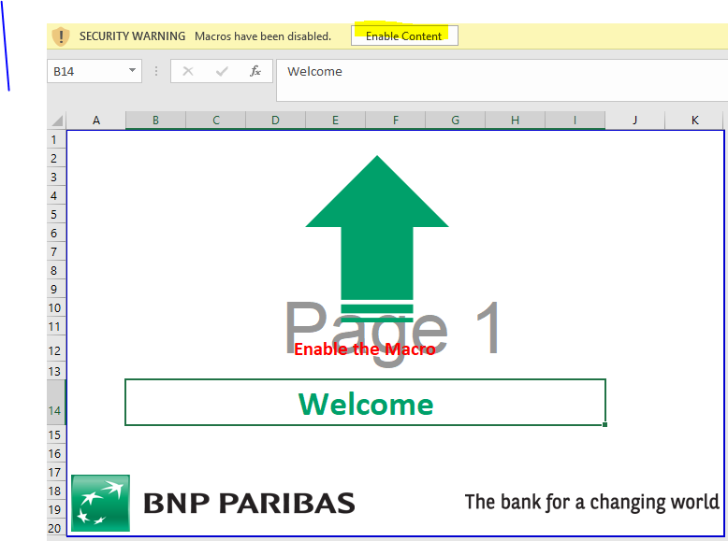

1. Enter the User name (**guest**) and the password (**guest@123**)

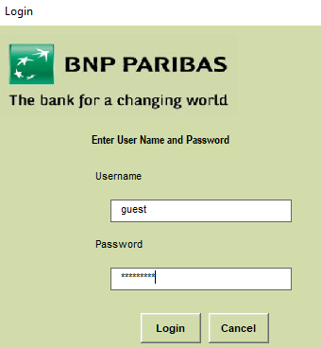

1. Select Modify, and select the applicable Entity from the list i.e. your joining entity

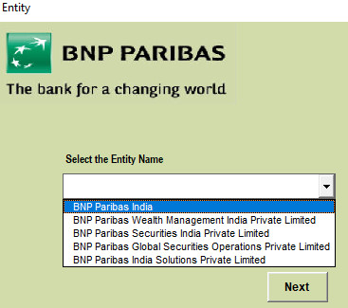

1. Select the location as per the work location.

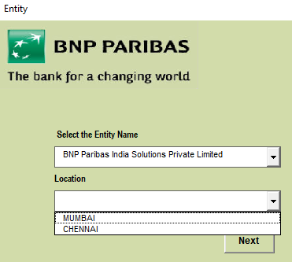

1. Fill all the personal details and go to the next tab.

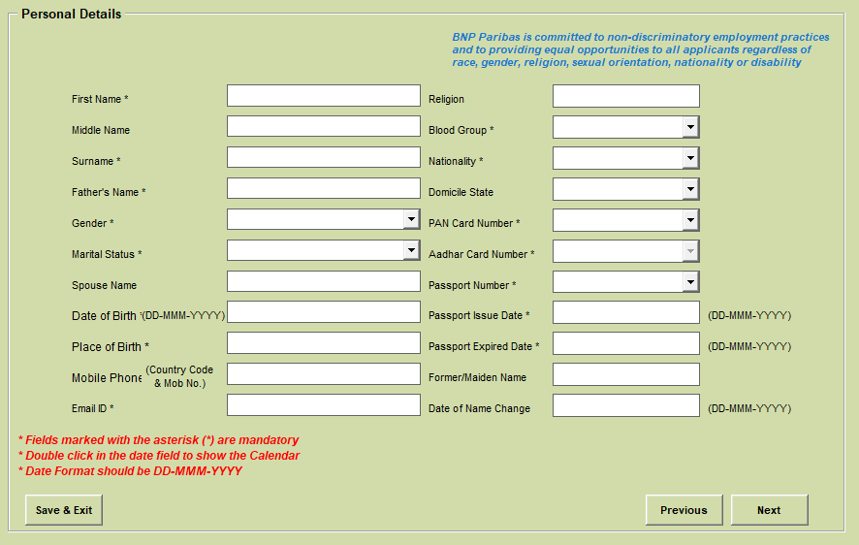

1. Fill address details. Click on “same as present” incase of your present & permanent address are the same. Click (+) sign to add rows.

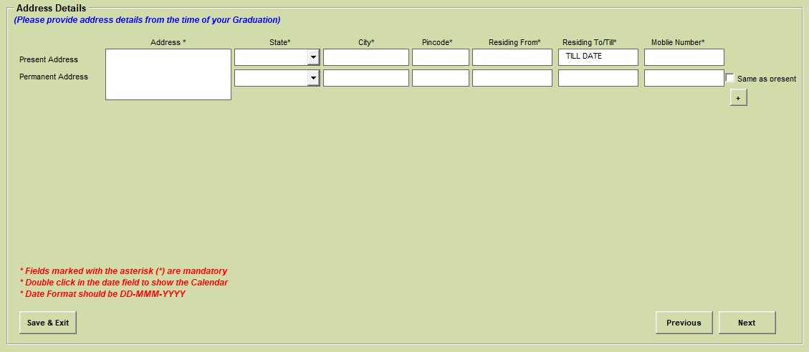

1. Fill all the education details starting from the recent qualification (graduation and above only).

Click (+) sign to add rows.

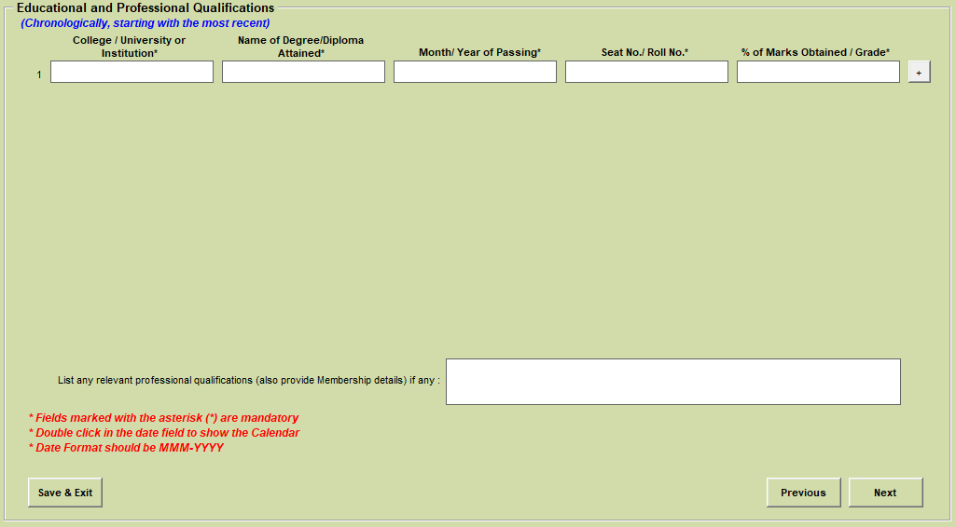

1. Fill in the Emergency and Family details carefully by giving the correct DOB of your family members.

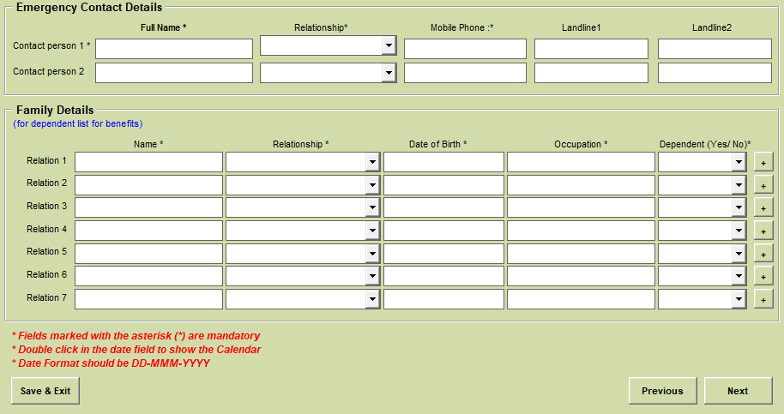

1. All the details should be filled under the work experience tab. Supervisor and manager details are mandatory and cannot be skipped.

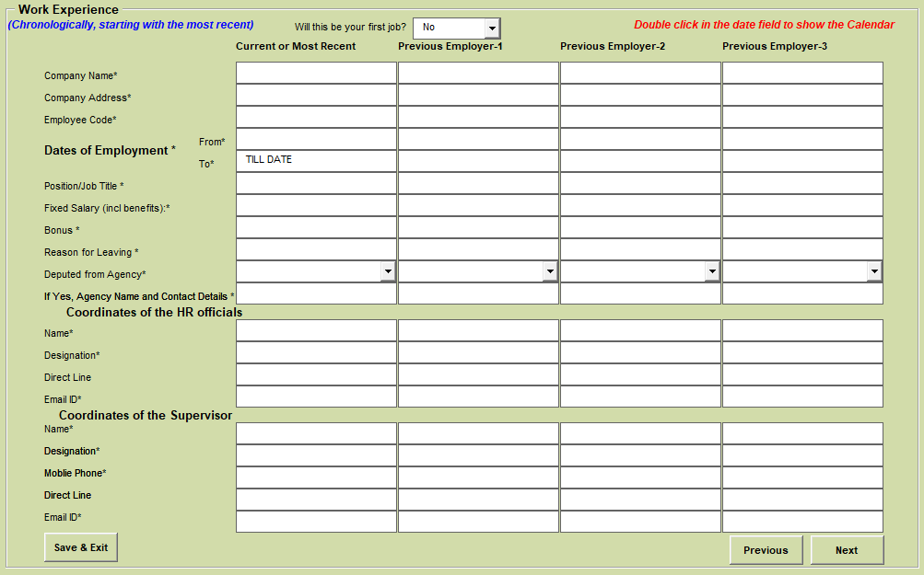

1. Experienced candidate should fill in the UAN/ PF account details by referring the pay slips.

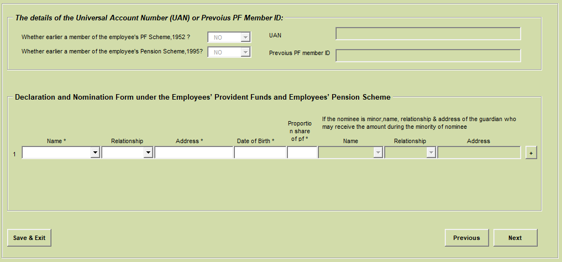

1. Double click on the tabs to populate the family member’s details for EPS nomination (Do not type)

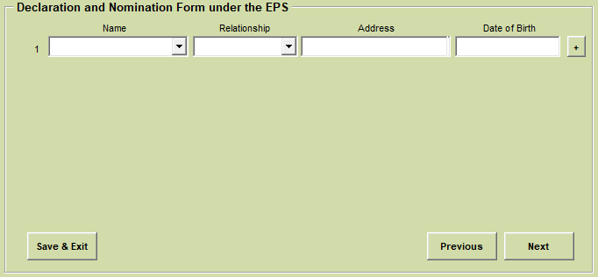

1. Double click on the tabs to populate the family member’s details for Gratuity nomination.

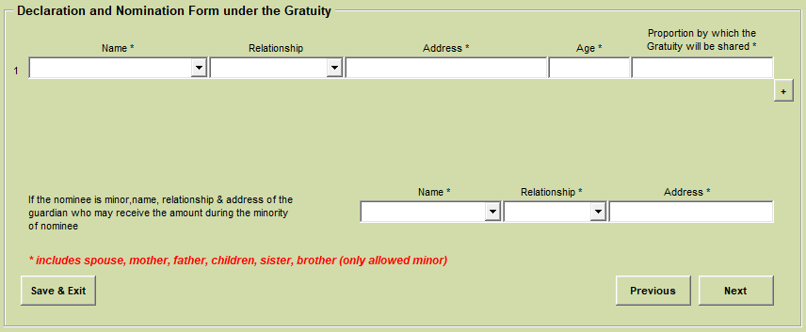

1. Double click on the tabs to populate the family member’s details for Insurance nomination

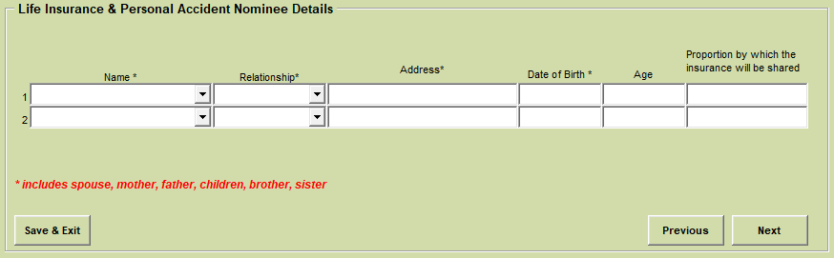

1. Read the below and answer the questions accordingly.

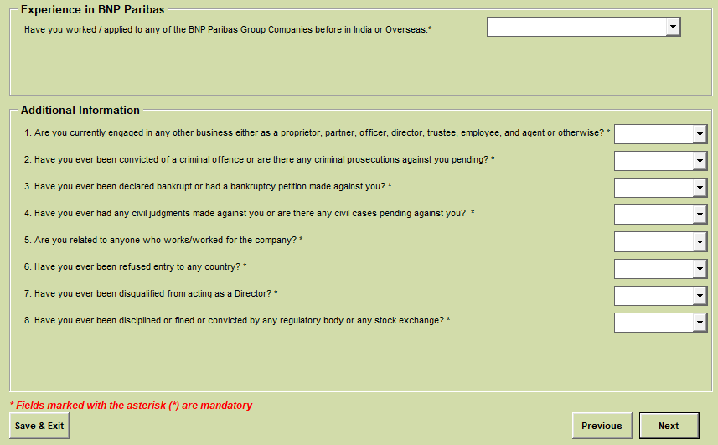

1. This is the last page. Save the documents and print as PDF. Sign on the 1st 4 pages of the employment form, scan the signed form and submit the document.

